Sales dataset

# Import Libraries
import pandas as pd
import numpy as np
import matplotlib.pyplot as plt
import seaborn as sns
import plotly.express as px
# Sample Sales Dataset (synthetic example)
data = {
'order_id': range(101, 201),
# Generate realistic-looking price and quantity data
'price_per_unit': abs(np.random.normal(50, 20, 100)).round(2),
'quantity_ordered': np.random.randint(1, 20, 100),
# Categorical variables
'product_category': np.random.choice(['Electronics', 'Apparel', 'Home Goods', 'Books', 'Outdoors'], 100),
'region': np.random.choice(['North', 'South', 'East', 'West'], 100),
'payment_method': np.random.choice(['Credit Card', 'PayPal', 'Wire Transfer'], 100)
}
df_sales = pd.DataFrame(data)
df_sales['total_sales'] = df_sales['price_per_unit'] * df_sales['quantity_ordered']
print(df_sales.head())
print("\nSummary Statistics:")
print(df_sales.describe())
print("\nProduct Category Counts:")
print(df_sales['product_category'].value_counts())
# Matplotlib Visualizations
# Bar Chart - Product Category Counts
df_sales['product_category'].value_counts().plot(kind='bar', color=['coral', 'lightblue', 'lightgreen', 'pink', 'purple'])
plt.title('Bar Chart - Product Category Counts')
plt.ylabel('Number of Orders')
plt.xticks(rotation=45)
plt.show()
# Line Chart - Total Sales of First 50 Orders
plt.plot(df_sales['total_sales'][:50], color='red')
plt.title('Line Chart - Total Sales (First 50 Orders)')
plt.xlabel('Order Index')
plt.ylabel('Total Sales ($)')
plt.show()
# Histogram - Price per Unit Distribution
plt.hist(df_sales['price_per_unit'], bins=20, color='darkorange', alpha=0.7)
plt.title('Histogram - Price Per Unit Distribution')
plt.xlabel('Price Per Unit ($)')
plt.ylabel('Frequency')
plt.show()
# Seaborn Statistical Plots
# Distribution Plot - Total Sales
sns.displot(df_sales['total_sales'], kde=True, color='blue')
plt.title('Distribution Plot - Total Sales')
plt.show()
# Box Plot - Total Sales by Region
plt.figure(figsize=(8, 6))
sns.boxplot(x='region', y='total_sales', data=df_sales, palette='Paired')
plt.title('Box Plot - Total Sales by Region')
plt.show()
# Count Plot - Payment Methods
plt.figure(figsize=(8, 6))
sns.countplot(x='payment_method', data=df_sales, palette='viridis')
plt.title('Count Plot - Preferred Payment Methods')
plt.xticks(rotation=0)
plt.show()
# Plotly Interactive Plots

# Interactive Distribution (Quantity Ordered by Region)
fig = px.histogram(df_sales, x='quantity_ordered', color='region',
title='Interactive Distribution of Quantity Ordered by Region',
labels={'quantity_ordered': 'Quantity Ordered', 'count': 'Frequency'},
marginal='box')
fig.show()
# Interactive Scatter Plot (Price vs. Quantity, colored by Category)
fig2 = px.scatter(df_sales, x='price_per_unit', y='quantity_ordered', color='product_category',
title='Interactive Scatter Plot: Price vs. Quantity by Category',
labels={'price_per_unit': 'Price Per Unit ($)', 'quantity_ordered': 'Quantity Ordered'},
hover_data=['order_id', 'total_sales'])
fig2.show()
print("✅ Sales Data Analysis Complete!")
output :
order_id price_per_unit quantity_ordered product_category region \
0 101 81.70 12 Outdoors East
1 102 29.13 7 Apparel South
2 103 15.74 7 Books East
3 104 32.05 17 Electronics West
4 105 66.44 5 Outdoors North

payment_method total_sales
0 Credit Card 980.40
1 PayPal 203.91
2 Credit Card 110.18
3 Credit Card 544.85
4 Credit Card 332.20

Summary Statistics:
order_id price_per_unit quantity_ordered total_sales
count 100.000000 100.000000 100.000000 100.000000
mean 150.500000 50.913500 10.140000 527.555700
std 29.011492 19.492194 5.301077 356.444175
min 101.000000 3.810000 1.000000 30.480000
25% 125.750000 37.912500 6.000000 236.035000
50% 150.500000 52.095000 9.500000 494.970000
75% 175.250000 66.290000 14.000000 734.505000
max 200.000000 96.210000 19.000000 1489.120000

Product Category Counts:
product_category
Home Goods 25
Outdoors 22
Electronics 20
Apparel 17
Books 16
Name: count, dtype: int64
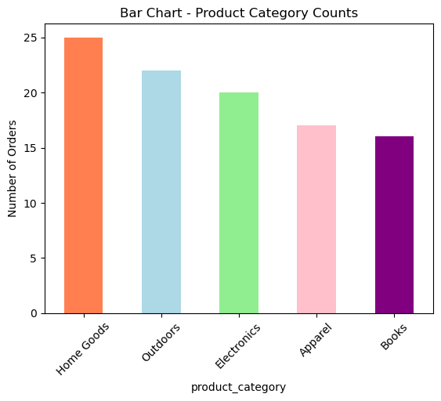
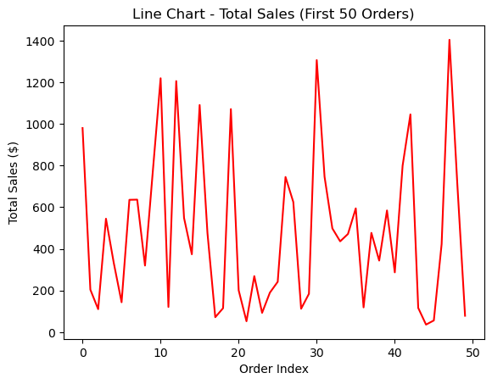
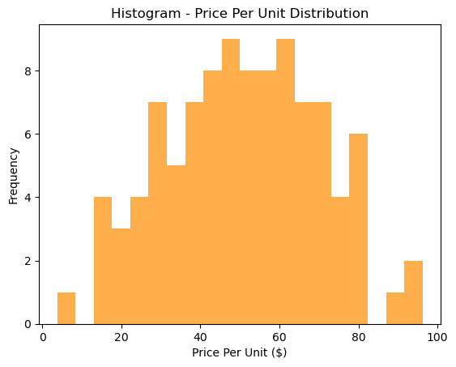
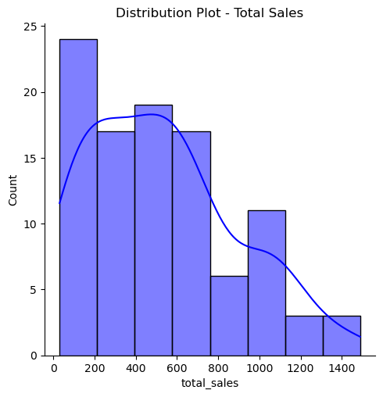
C:\Users\aiml-lab\AppData\Local\Temp\ipykernel_16584\503791604.py:70: FutureWarning:

Passing `palette` without assigning `hue` is deprecated and will be removed in v0.14.0. Assign the `x` variable to `hue` and set `legend=False` for the same effect.

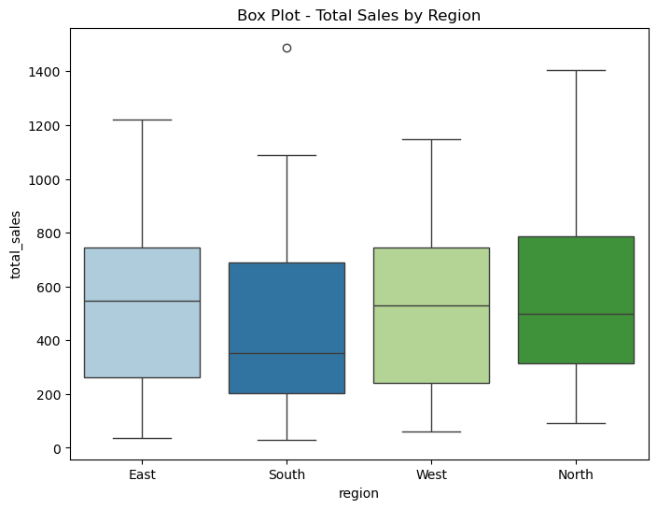
C:\Users\aiml-lab\AppData\Local\Temp\ipykernel_16584\503791604.py:76: FutureWarning:

Passing `palette` without assigning `hue` is deprecated and will be removed in v0.14.0. Assign the `x` variable to `hue` and set `legend=False` for the same effect.

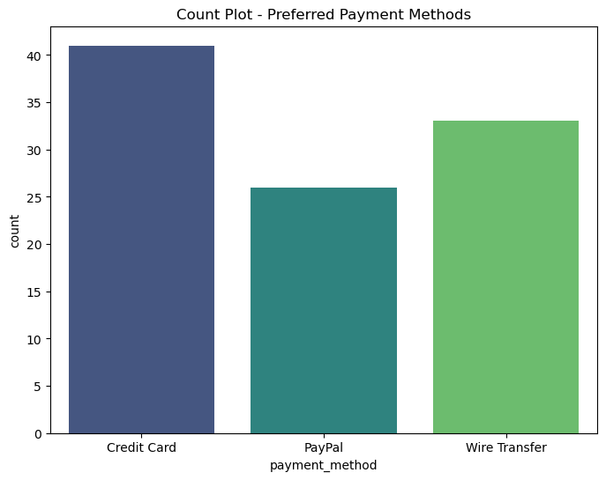
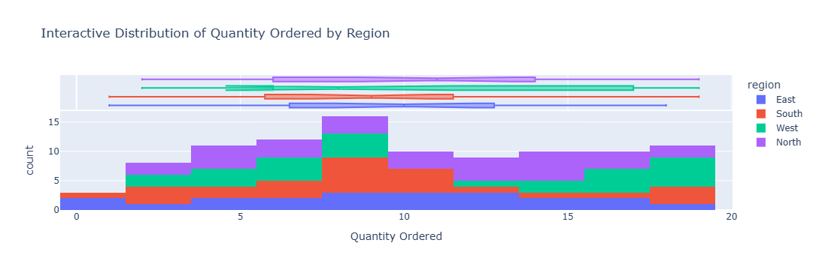
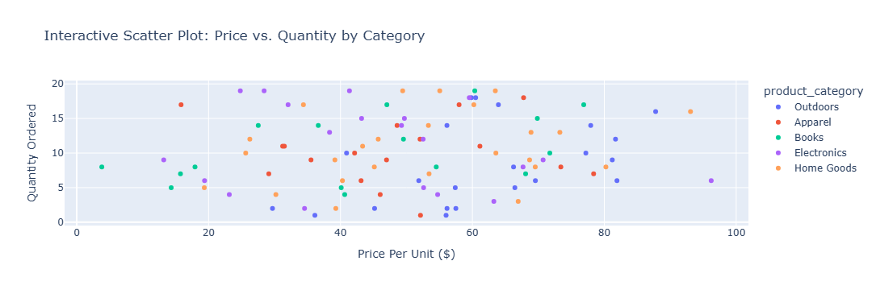
✅ Sales Data Analysis Complete!

